### **Bug Report: Tata Digital Website**

#### **Bugs Identified:**

1. **Form Submission Error**
   * **Description:** The form submission fails with the message: "Unable to submit the form! An error occurred during the form submission. Please try again later.".
2. **Missing Content in Press Releases**
   * **Description:** Press release content is missing for the years 2020 and 2023. The section states "No articles available" for 2020.
3. **Incorrect Navigation for "Find Us"**
   * **Description:** The "Find Us" link navigates incorrectly, leading users to an unintended or wrong destination.

#### **Attachments:**

Screenshots are provided for visual reference of the above issues:  
  
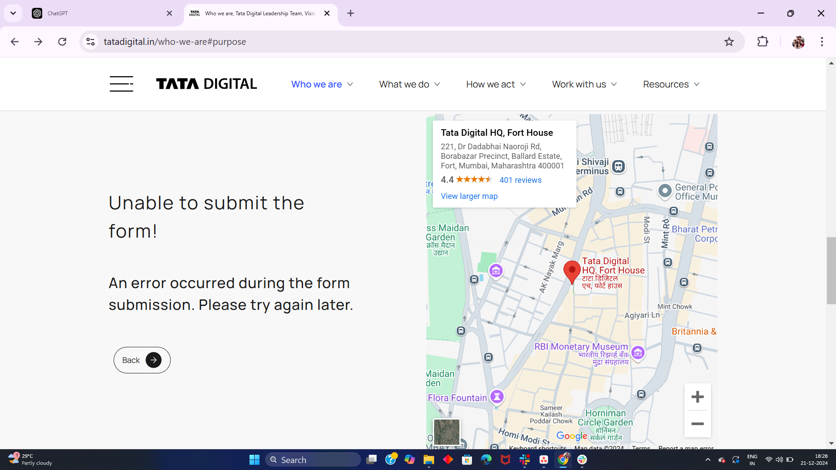 **Form Submission Error**

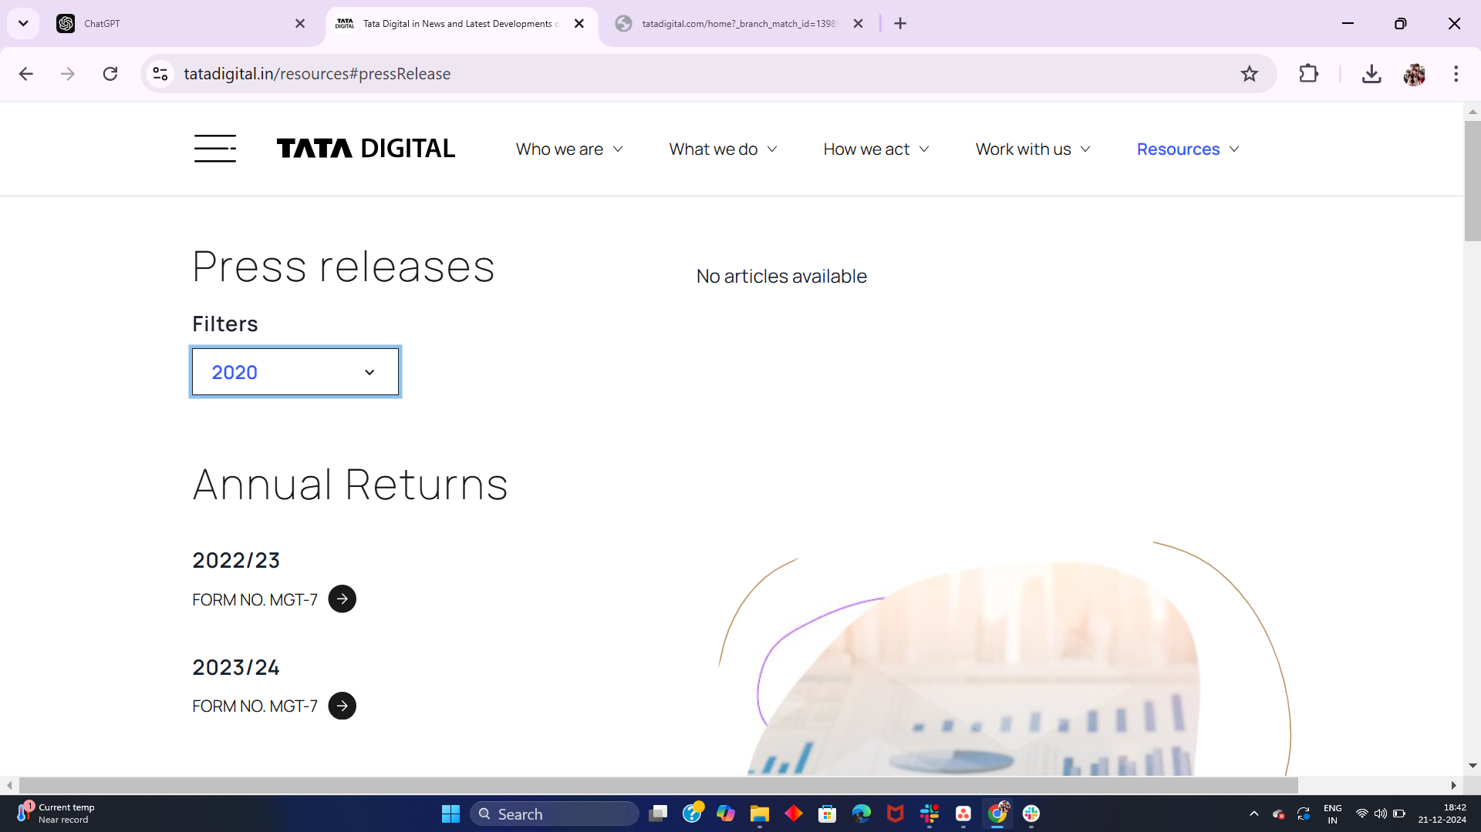

**Press Releases**

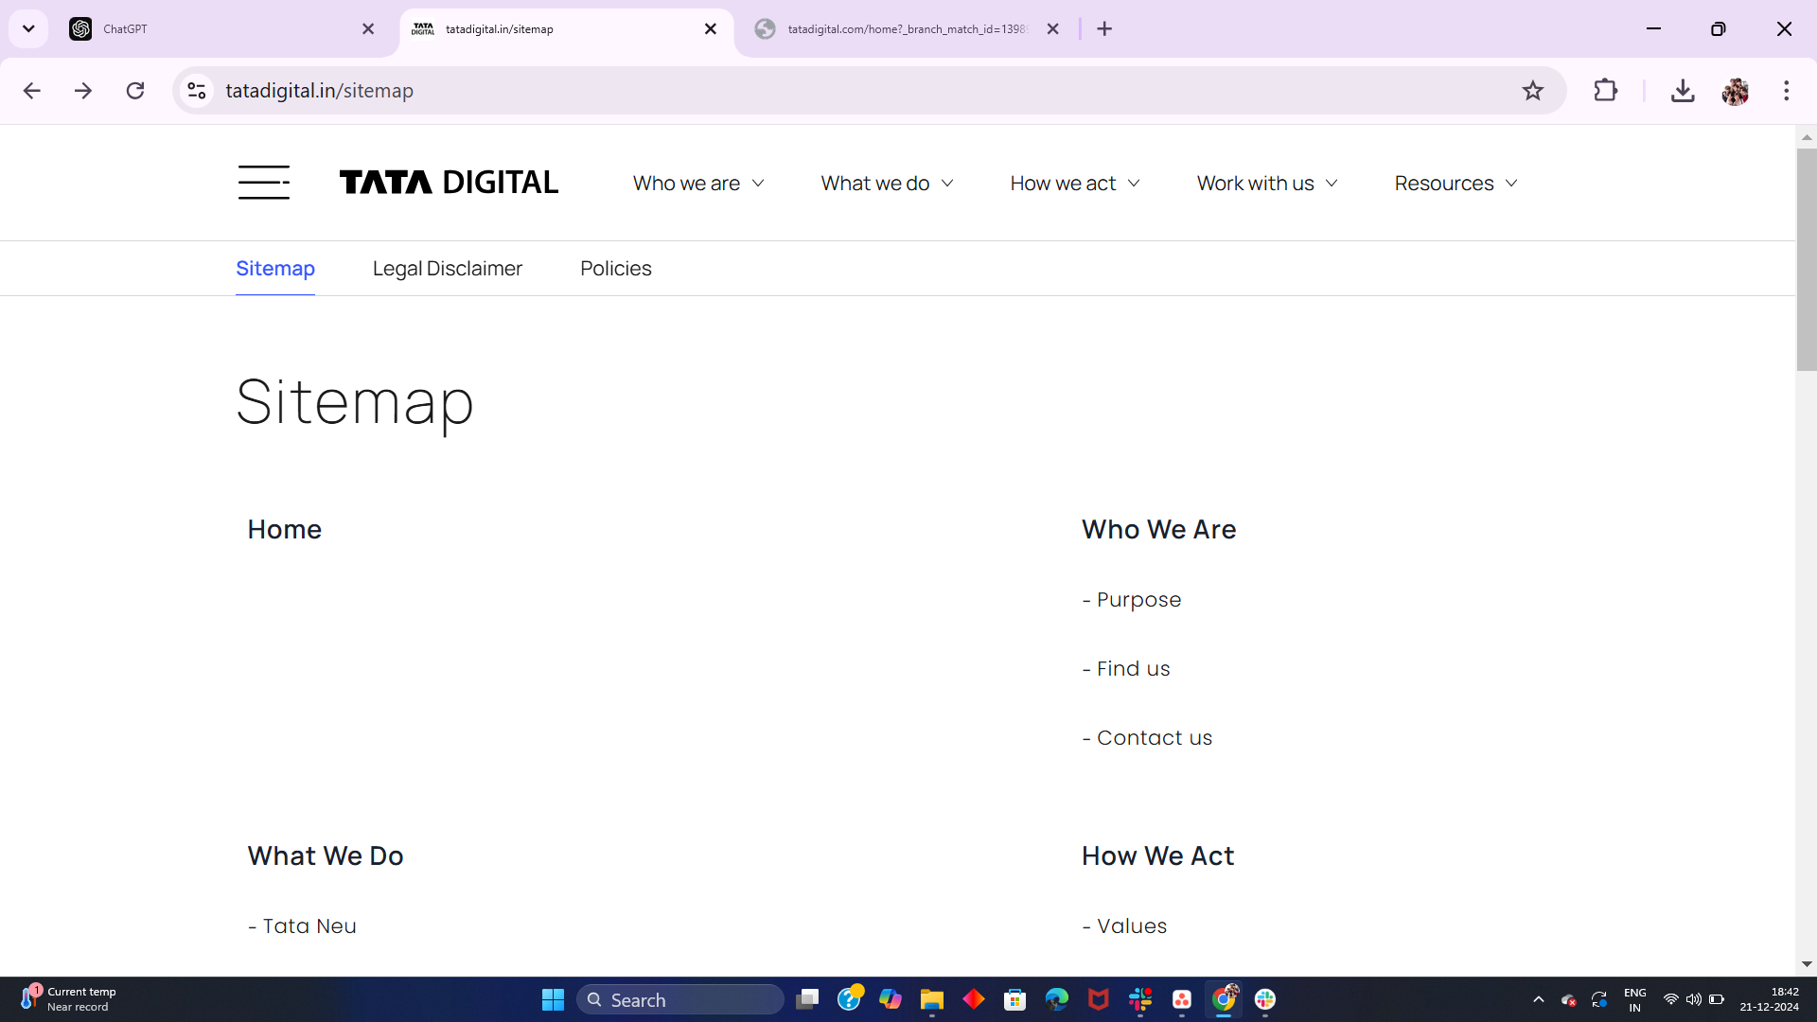

**Find Us Navigation**

#### **Priority:**

* **High:** Form submission and navigation errors.
* **Medium:** Missing press release content.